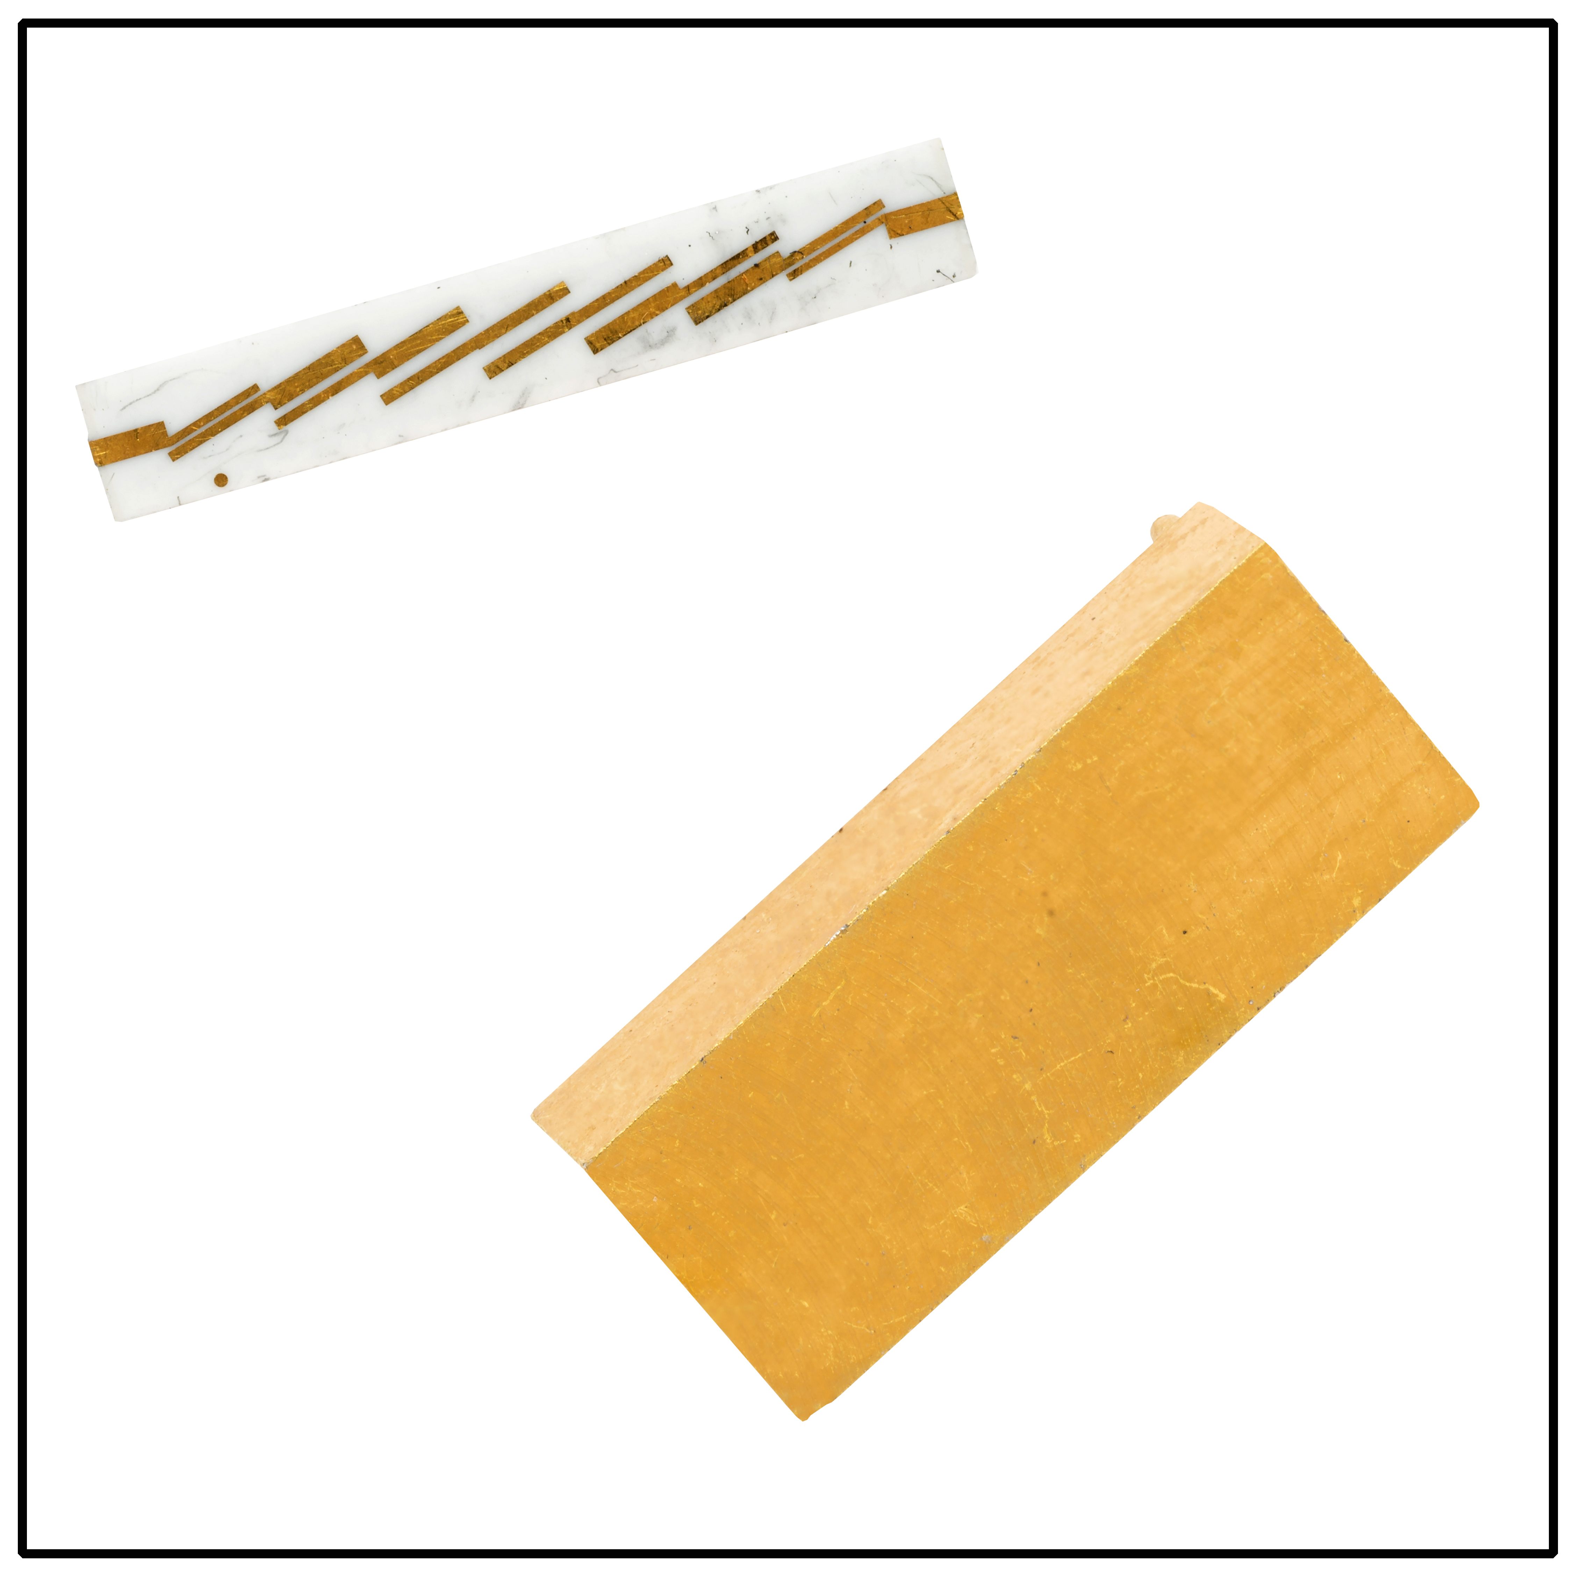
FOR IMMEDIATE RELEASE
April 5, 2017
For additional information contact:
Mr. CJ McBride
Corry Micronics, Inc.
761 Commonwealth Drive
Warrendale, PA 15086
724-940-7556 ext 138
Fax: 724-940-7707
E-mail: cmcbride@cormic.com

Corry Micronics Inc. offers Airborne K Band Strip Line Filter

Warrendale, PA - Corry Micronics has recently designed and manufactured strip line bandpass filters with a center frequency of 23GHz. Don Pavlek, President and CEO of Corry Micronics stated, “CMI had been requested by a major social media company to create an extremely light weight filter for their communication drones.” Pavlek went on to say, “Our engineering staff faced several design challenges. After many hours of design simulations and build constraints CMI was able to meet every customer specification.”

One of the most challenging specifications was that our customer requested the filter be surface mountable, pick and placed and installation would use standard off the shelf solders. Jim Price, VP of Engineering said, “We like new and difficult challenges and this was certainly one that tested our staff’s abilities.”

The filter enclosed in a gold-plated housing weighs only 0.46 grams or 0.0163 oz. The overall size is 0.5” by 0.2” by 0.115”. The small form factor and weight make it a perfect fit for all applications but especially for airborne application where weight and size are critically important.

Call Corry Micronics’ sales today with your custom filter request. Our sales group will but you directly in touch with our engineering staff. Working together we will provide you with several filtering options that will solve your problem.

Contact Micronics’ Vice President of Sales, CJ McBride at 724-940-7556 ext 138 or by e-mail at cmcbride@cormic.com. Check our website www.cormic.com (and the page from our website)

