

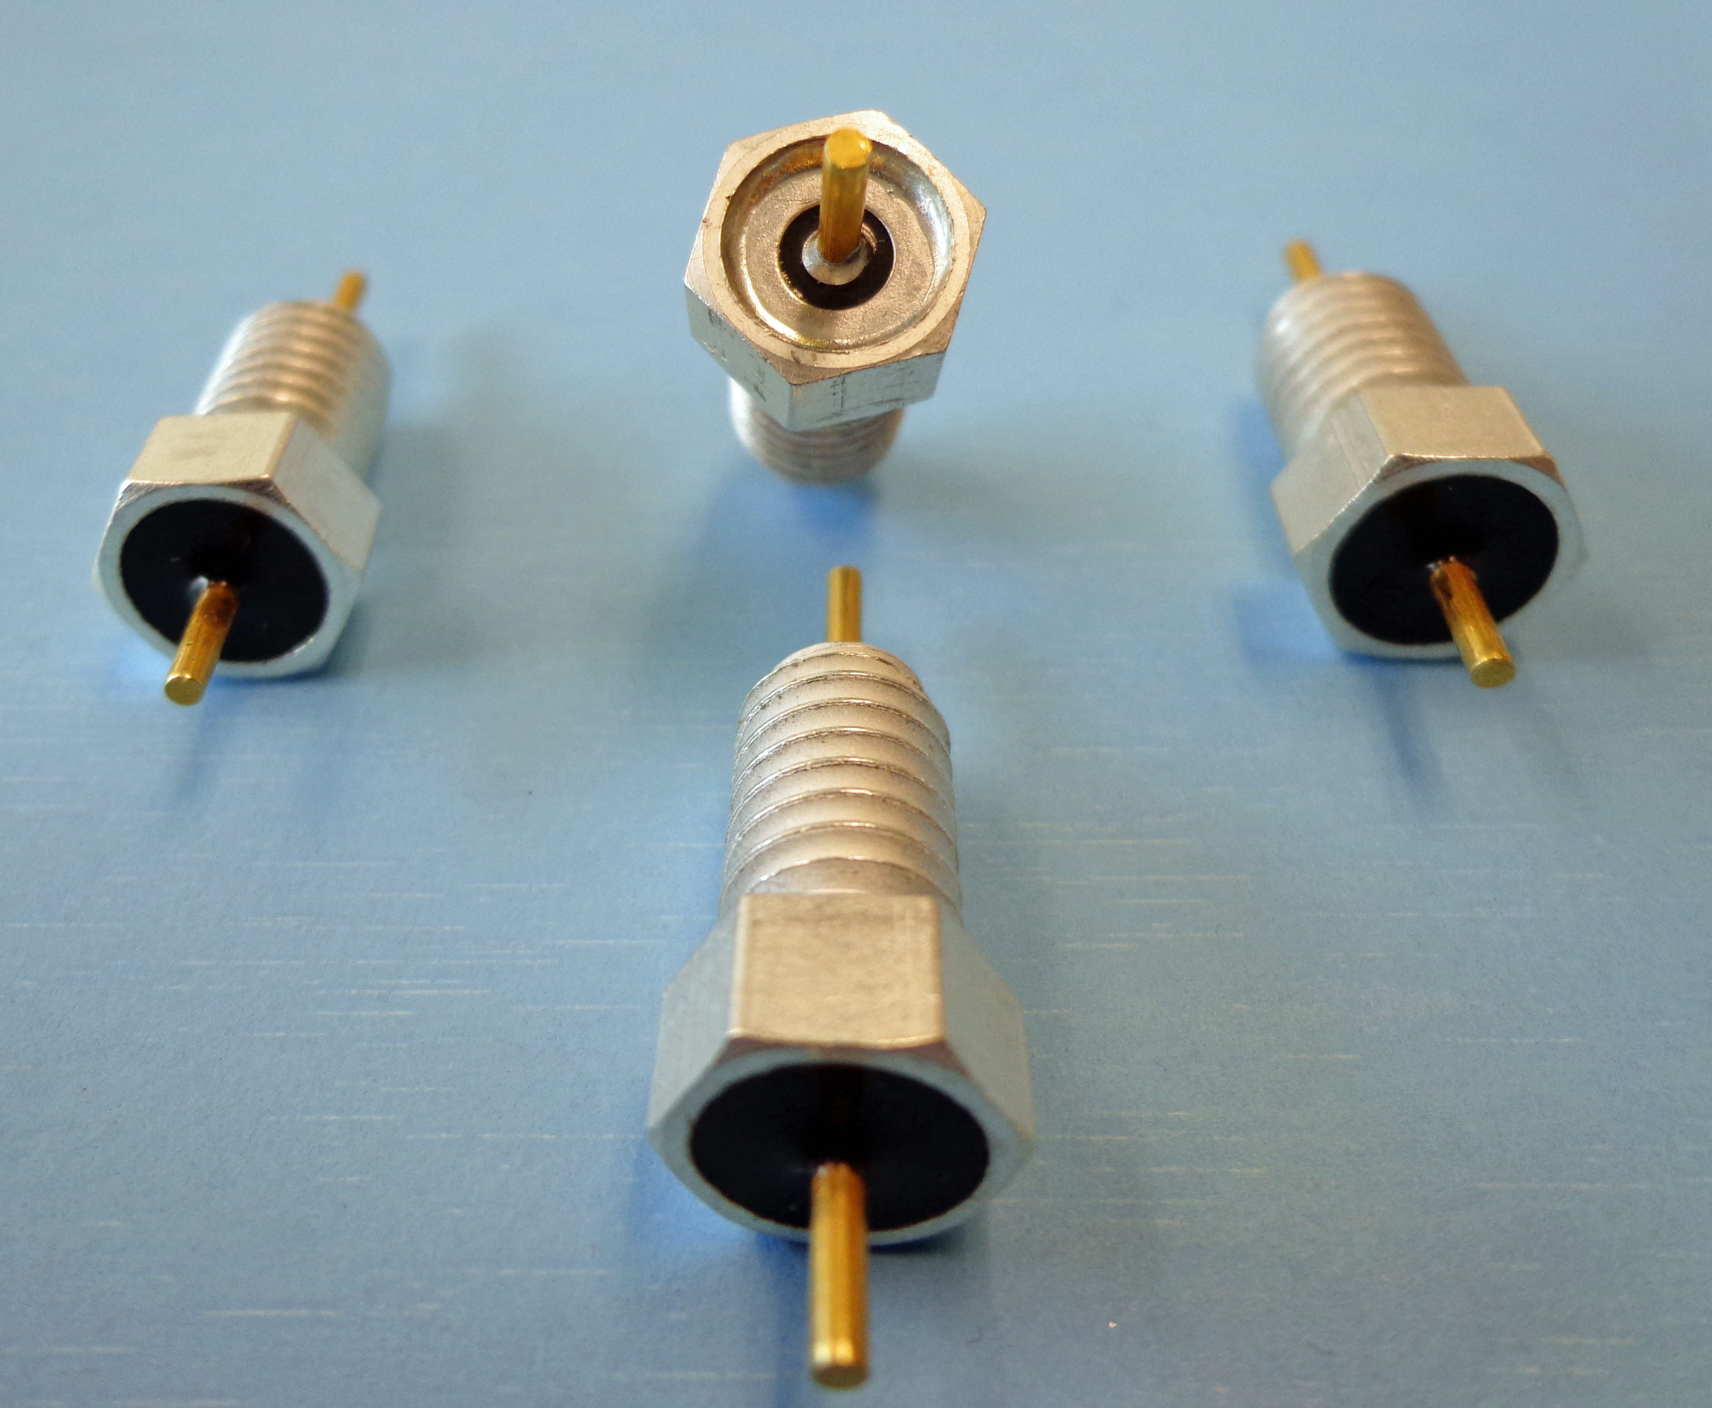
FOR IMMEDIATE RELEASE
May 31, 2013
For additional information contact:
Mr. CJ McBride
Corry Micronics, Inc.
One Plastics Road
Corry, PA 16407
724-940-7556 ext 138
Fax: 724-940-7707
E-mail: cmcbride@cormic.com

Corry Micronics Inc. offers a Hermetic Bolt-in Feedthru

Corry, PA- May 31, 2013 - Corry Micronics has released their Resin/Glass-Sealed Hermetic Bolt-in style Feedthru designed specifically for the industrial process management industry. The harsh environmental requirements being applied to this growing industry continues to create challenges as design engineers attempt to meet more stringent safety guidelines and keep high reliability component cost down. Corry Micronics has been designing and manufacturing EMI Filters and Feedthru components for process control equipment since 1970 and is constantly striving to provide the highest quality products for this challenging field. The Corry FTF12 Series was specifically created with hardened process management applications in mind and features the following attributes:

- Hermetically tested to exceed gross leak 1x10(-5) cc-He/SEC@1Atm
- Pressure Tested in applications to 150psi
- Case is designed to exceed flame path and explosion-proof requirements
- Ideally designed for harsh environments like those found in gas & oil refinery facilities

**Note** Unit can be modified to meet your specific requirements. Please contact sales to discuss design and pricing options

Contact Micronics’ Director of Sales, CJ McBride at 724-940-7556 ext 138 or by e-mail at cmcbride@cormic.com.

