

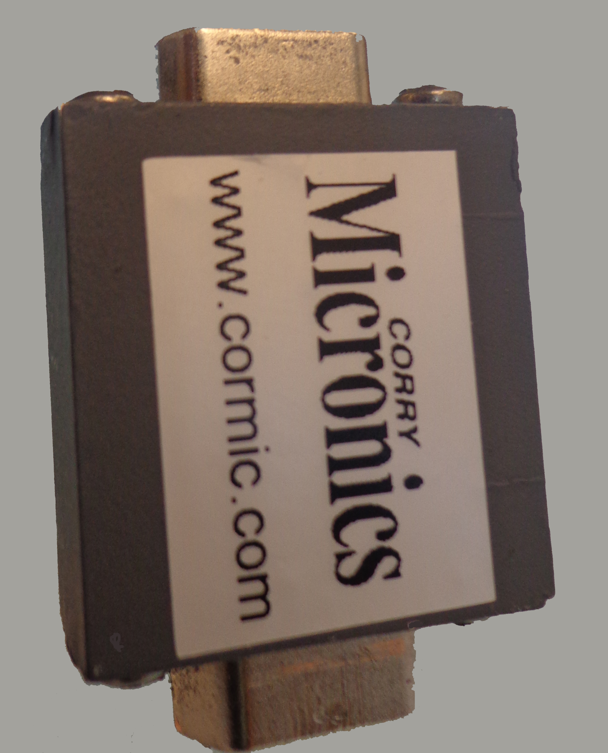
FOR IMMEDIATE RELEASE
November 7, 2013
For additional information contact:
Mr. CJ McBride
Corry Micronics, Inc.
One Plastics Road
Corry, PA 16407
724-940-7556 ext 138
Fax: 724-940-7707
E-mail: cmcbride@cormic.com

Corry Micronics Inc. offers Filtered Micro-D Sub Adapters

Corry, PA- November 7, 2013 - Corry Micronics has released their filtered micro-d sub adapter product line for direct sale. Don Pavlek, President and CEO of Corry Micronics stated that the company has been manufacturing industry-standard filtered d-sub adapters for over 10 years but customer demand for filtered micro-d sub adapters has increased over the past 12 months. Pavlek stated that several of his existing customers had requested that Corry Micronics produce the filtered micro d-sub adapter product line because customers were seeing increased pricing and lead times from other suppliers.

Corry Micronics’ filtered micro d-sub adapters are constructed with machined aluminum housings and ceramic planars for “C” type circuits and with added ferrites for the “Pi” configurations. Our product entry covers pin counts from 9 to 37.

Corry Micronics is offering two styles; capacitive “C” and Pi filtering options are available with a standard capacitive range of 400 pF to 56,000 pF in the Pi configuration, and up to 28,000 pF in the “C” configuration. Custom configurations are also available with small minimum order requirements. The standard DC working voltage is 100 volts with a withstanding voltage rating of 250 VDC.

Call Corry Micronics’ sales office today to find out how other Corry Micronics’ customers have been able to significantly reduce their lead times and cost. The first shipments of filtered micro d-sub adapters are scheduled to ship by the end of the year.

Contact Micronics’ Director of Sales, CJ McBride at 724-940-7556 ext 138 or by e-mail at cmcbride@cormic.com. Check our website www.cormic.com or http://www.cormic.com/multiplelinefilters.html

